Inaugural ceremony of the ECCD centre at Lingzhi

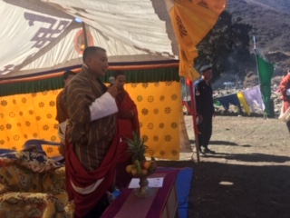
Dasho Dorji Tshering, Dzongdag, Thimphu Dzongkhag inaugurated the ECCD centre at Lingzhi on 25th April 2019. 18 children and parents attended the program.

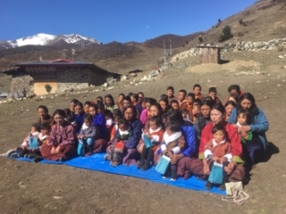
After the inauguration ceremony, the parents were oriented on the importance and benefits of Early Child Care and Development programs.

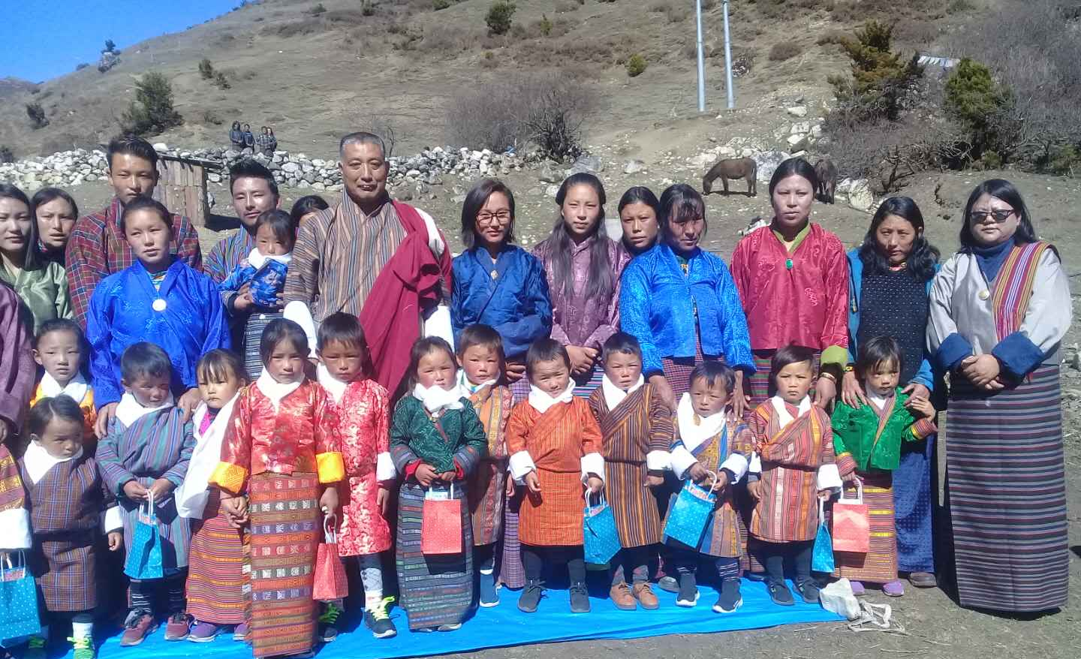

The ECCD centre at Gangyul and Chaphu were established with financial support from the UNICEF.

